Request for a Scientific Peer Review of DEQ’s Assessment Methodology for Lake/Reservoir Dissolved Oxygen

## Introduction

States, territories, and authorized tribes must ensure their water quality standards (WQS) are met. As mandated by the Clean Water Act, they must monitor parameters that enable criteria assessment, report assessment information to the public and to the Environmental Protection Agency (EPA), and identify impaired waters (those not meeting WQS) so that appropriate measures can be implemented to restore designated uses (e.g., Total Maximum Daily Load implementation plans). To provide transparency, jurisdictions must describe how they determine whether their WQS are being met. This description is usually not included in the WQS regulation, but instead is typically published separately in a public-facing document devoted solely to implementation procedures. The Virginia Department of Environmental Quality (DEQ) presents its water quality assessment methodology in a document called the Water Quality Assessment Guidance Manual (hereafter referred to as the “guidance manual”). The guidance manual not only shows the public how DEQ determines whether a water body meets its designated uses, but it also serves as an instruction manual for staff so that surface waters across the Commonwealth are assessed consistently and defensibly.

As with anything, assessment methodology can be strong in some areas and weak in others (Table 1). Frequently, weaknesses are detected by new staff members, who tend to read the instructions from a different perspective than more veteran staff members. Sometimes weaknesses are brought to DEQ’s attention by informed members of the public, EPA, or the regulated community. Updates are made every two years to the guidance manual to address weaknesses and to ensure that procedures reflect newly adopted or modified WQS and updated guidelines from EPA. DEQ’s Integrated Water Quality Assessment Report, which includes the Impaired Waters List, is largely the end result of the data analyses described in the guidance manual.

**Table 1. Distinguishing marks of strong and weak assessment methodology**



In 2005, the Academic Advisory Committee (AAC) submitted a report to DEQ entitled “Freshwater Nutrient Criteria” that was used to inform the development of nutrient criteria for a large subset of Virginia lakes/reservoirs studied by the AAC. These water bodies were deemed “significant” and include the Commonwealth’s two natural lakes and 122 man-made reservoirs. A significant lake/reservoir is defined as a publicly accessible lake/reservoir that is a public water supply and/or 100 acres or more in size. Total chlorophyll-a and total phosphorus (TP) criteria became effective for these lakes/reservoirs in 2007 and are listed in [9 VAC 25-260-187](http://lis.virginia.gov/cgi-bin/legp604.exe?000+reg+9VAC25-260-187) and [9 VAC 25-260-310](http://lis.virginia.gov/cgi-bin/legp604.exe?000+reg+9VAC25-260-310) of the WQS regulation. Along with providing the agency with recommendations for nutrient criteria, the AAC also advised DEQ on how dissolved oxygen (DO) criteria should be applied to lakes/reservoirs ([Appendix C](https://www.deq.virginia.gov/Portals/0/DEQ/Water/WaterQualityStandards/AACLAKEDO.pdf) in AAC, 2005). These recommendations were used to support the inclusion of language in [9 VAC25-260-50](http://lis.virginia.gov/cgi-bin/legp604.exe?000+reg+9VAC25-260-50) stipulating that DO and pH apply only to the epilimnion of a thermally stratified man-made lake or reservoir listed in [9 VAC 25-260-187](http://lis.virginia.gov/cgi-bin/legp604.exe?000+reg+9VAC25-260-187) (hereafter referred to as Section 187 lakes/reservoirs). Prior to the adoption of this language, DEQ applied DO criteria to the entire water column of both stratified and non-stratified water bodies, which resulted in a number of reservoirs being categorized as impaired when their low DO condition was not due to anthropogenic inputs (e.g., nutrients).

Apart from these recommendations, however, the AAC did not find fault with DEQ’s assessment procedures for DO in lakes/reservoirs. The AAC’s report describes DEQ’s methodology as “sound” and “scientifically defensible”. It should be noted that the AAC report does not specifically describe DEQ’s DO assessment methodology, but the 2004 DEQ Water Quality Assessment Guidance Manual is cited in the reference section. The 2004 guidance manual instructed DEQ staff to apply DO criteria to lakes/reservoirs in the following manner (bolding added):

*Epilimnion:*

**For each monitoring station**, all DO data collected in the epilimnion (delineated using temperature profile or assumed to be the upper 1/3 of the water column) will be **aggregated** and assessed. If the violation rate exceeds 10%, the assessment unit or entire lake/reservoir will be assessed as impaired partially due to one or more pollutants from anthropogenic sources and will be placed in category 5A for TMDL development. If the violation rate is less than 10.5%, assess the hypolimnion.

*Hypolimnion:*

**For each monitoring station**, all data collected in the hypolimnion (delineated using temperature profile or assumed to be the lower 2/3 of the water column) will be **aggregated** and assessed. If the violation rate exceeds 10.5%, the lake/reservoir will be assessed as impaired partially due to one or more pollutants. Calculate the Tropic State Indices to determine whether the violations are due to pollutants from anthropogenic sources or natural sources. If the violation rate is less than 10.5%, the assessment unit or lake will be assessed as fully supporting.

*Non-stratfied Lakes - Water Column Treated as Homogenous Unit:*

If the lake is not stratified (Tt and Tb differential <4ºC) all DO data in the water column will be **aggregated** and assessed. If the violation rate exceeds 10.5%, the assessment unit or entire lake/reservoir will be assessed as impaired partially due to one or more pollutants from anthropogenic sources and will be placed in category 5A for TMDL development. If the violation rate is less than 10.5%, the assessment unit or lake will be assessed as fully supporting.

After 2007, the water quality assessment guidance manual was updated in light of the aforementioned adoptions to the lakes/reservoirs WQS. The 2018 guidance manual instructed DEQ staff to apply DO criteria to lakes/reservoirs in the following manner (bolding in original):

The 10.5% rule is applicable to assessments for the minimum dissolved oxygen criterion in all assessed lakes and reservoirs for each lake monitoring year. For §187 lakes/reservoirs, dissolved oxygen samples taken for all months within the lake monitoring year, at all stations within a given lake or reservoir, are assessed only in the epilimnion if the water body is thermally stratified. If not stratified, dissolved oxygen should be assessed throughout the water column. A lake or reservoir is considered stratified if there is a difference of 1ºC /meter. If the differential is < 1ºC /meter, the lake is not considered stratified. Lakes/Reservoirs not listed in §187 should have all DO samples assessed regardless of thermal stratification determination. Two or more exceedances and >10.5% exceedance of total samples are required before a water body is listed as impaired for the minimum dissolved oxygen criterion (4 mg/l for most freshwater lakes and reservoirs) under § 62.1-44.19:5 and 7 of the Code of Virginia.

There are some key differences in the 2004 and 2018 instructions besides the treatment of hypolimnion data. First, the 2004 guidance manual instructed staff to apply the “10.5% rule”[1] to “each monitoring station” dataset in a lake/reservoir, while the 2018 guidance directed staff to apply the rule to “all dissolved oxygen samples” within a lake/reservoir. Secondly, the 2004 guidance manual uses the term “aggregate,” while that term does not appear in the more recent guidance manual. The AAC members who may have reviewed the lakes/reservoirs section of the 2004 guidance manual may have assumed the term “aggregate” meant that DEQ staff were being instructed to average epilimnetic samples (or water column samples in non-stratified water bodies) by monitoring station. However, DEQ staff interpreted “aggregate” to mean that samples would be assessed collectively, with no averaging. “Aggregate” was likely dropped in subsequent versions of the guidance manual due to the ambiguity of this term.

It is quite possible that the AAC would have still determined that DEQ’s DO assessment methodology for lakes/reservoirs was scientifically defensible even if “aggregate” had not been used in the 2004 guidance. But there is enough of a difference between the 2004 and 2018 guidance instructions to warrant a new AAC review to ensure that DEQ’s procedure is sound and scientifically defensible. This review would also be helpful given DEQ’s desire to update the guidance for the [Monitoring and Assessment of Lakes and Reservoirs](https://townhall.virginia.gov/L/GetFile.cfm?File=C:\TownHall\docroot\GuidanceDocs\440\GDoc_DEQ_3959_v1.pdf), which provides general guidance for collecting and analyzing lake data. This guidance document was last finalized in 2009. During the spring of 2019, changes were proposed for this document and public comments were submitted to DEQ in response, but the changes were withdrawn due to staff uncertainty. The expertise of the AAC may help resolve this uncertainty.

DEQ requests a review of its current process for assessing DO in lakes/reservoirs to make sure that the AAC still considers it “sound” and “scientifically defensible.” DEQ would also appreciate a technical review of an alternative procedure that reflects staff recommendations combined with the suggestions submitted by a commenter regarding pH criteria assessment. Additionally, advice is requested on how DEQ should handle the assessment of low DO conditions caused by incomplete fall turnover. The AAC is asked to consider DEQ’s assessment methodology and any changes the AAC recommends with respect to the distinguishing marks listed in Table 1. This paper concludes with questions to assist the AAC with its responses.

### Current Process

DEQ staff typically create assessment units for water bodies they judge to be relatively homogeneous—one where surrounding land uses and riverine inputs are expected to be relatively uniform and one where physical dynamics (e.g., thermal stratification) are expected to be similar throughout. While DEQ staff tend to establish riverine assessment units around individual DEQ stations (one ambient water quality monitoring station per assessment unit), it is normal for multiple stations to be located in a single lake/reservoir assessment unit[2]. This is especially true for lakes/reservoirs that are monitored by other data collectors besides DEQ, like citizen groups. The number of non-agency stations is expected to multiply as citizen scientists continue to swell in number. Thus, it is important that there be standardization in the handling of different lake/reservoir datasets.

DEQ staff pool data by taking all measurements taken in the epilimnion (for Section 187 lakes/reservoirs) or in the water column (for non-Section 187 lakes or when Section 187 lakes/reservoirs are not stratified) over the six-year assessment period (Figure 1). Vertical temperature profiles enable assessors to determine the bottommost depth of the epiliminion at a station during a monitoring event. Epilimnetic samples are then compared to the minimum DO criterion (4.0 mg/l for most lakes/reservoirs). If more than 10% of these samples are below the criterion, then the lake/reservoir assessment unit will be deemed impaired for DO.

**DO Assessment Summary**

2+0+3 = 5 DO exceedances

31+4+32 = 67 epilimnetic DO measurements

Exceedance rate = 5/67 = 7%=>Criterion Attained

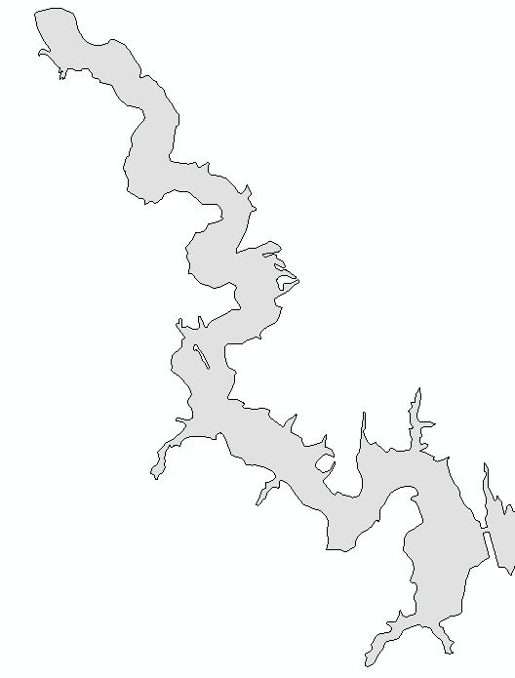

**Station C (DEQ)**

- 7 monitoring events

- 3 DO exceedances

- 32 epilimnetic DO

measurements over all

monitoring events

**Station B (Non-Agency)**

- 4 monitoring events

- 0 DO exceedances

- 4 epilimnetic DO

measurements over all monitoring events

**Station A (DEQ)**

- 7 monitoring events

- 2 DO exceedances

- 31 epilimnetic DO

measurements over all monitoring

events

**Figure 1. Illustration of how DEQ currently assesses DO samples in a hypothetical lake/reservoir assessment unit. Table 2 shows the hypothetical assessment dataset.**

**Table 2. Current assessment procedure applied to DO (mg/l) samples for the hypothetical stations shown in Figure 1. Underlined measurements are the bottommost epilimnetic measurements. Only the data in the gray box would be used to a calculate an exceedance rate for the assessment unit. Red values are DO criterion exceedance (< 4.0 mg/l).**

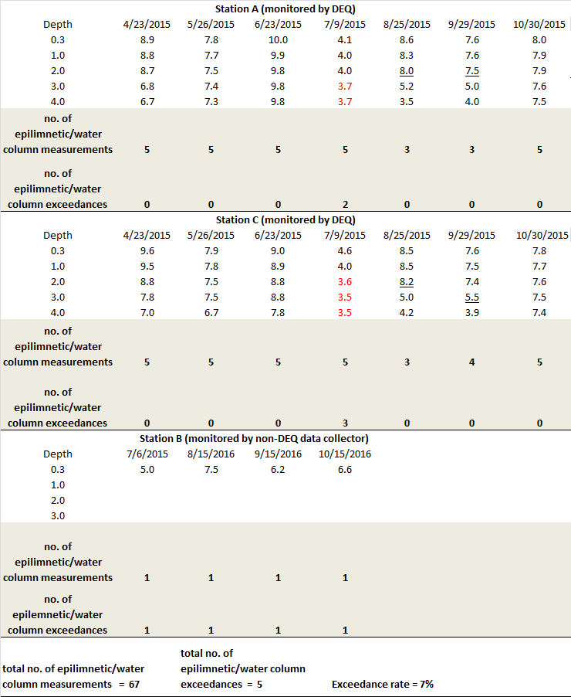

There have been no objections expressed from the public or EPA about this assessment approach, but questions have been raised internally about whether pooling data in this fashion would be considered a “best practice.” One concern is that this approach does not distinguish dependent samples (those collected on the same day, whether at different stations or at the same station within minutes and meters of each other) from independent samples (samples collected a month a part). While EPA guidance does not explicitly restrict the “10% rule” to independent samples and applying it to a collection of dependent samples is certainly a defensible approach, using it to evaluate a mix of dependent and independent samples seems questionable. When temporally independent samples meet the 10% rule, an assessor can conclude that a water body was in compliance with a particular criterion at least 90% of the time a water body was visited. When spatially dependent samples meet the 10% rule, an assessor can conclude that at least 90% of the habitat was in compliance with the criterion. But a dynamic mix of independent and dependent samples does not lend itself to a definitive conclusion about a water body’s condition. For instance, if more than 10% of such samples exceed the criterion, it could be that the water body is frequently in non-compliance at one or more depths in the epiliminion. Or it could be that a severe algal bloom resulted in low DO throughout the water column a couple of times during the two years a water body was monitored over the assessment period, and that 100% of the epilimnion was suitable for aquatic life on the rest of the monitored days. Thus, the ratio of the number of exceedances to the number of epilimnetic/water column measurements does not readily communicate whether the aquatic life in a water body is exposed to partially suboptimal habitat frequently or completely suboptimal habitat sporadically. By determining that both of these conditions indicate impairment, the agency is assuming they are equivalent losses of the aquatic life use. Perhaps that is not the case.

The questionable defensibility of this pooling approach was recently brought to staff attention in the context of nutrient criteria assessment in lakes/reservoirs. Until recently, staff has been processing nutrient datasets similar to how they have been processing DO datasets. However, unlike DO criteria, nutrient criteria are almost always paired with basic implementation procedures in the WQS to help ensure that these criteria are assessed in a manner consistent with their derivation. The following language can be found in [Section 187](http://lis.virginia.gov/cgi-bin/legp604.exe?000+reg+9VAC25-260-187) of the WQS (bolding added):

The 90th percentile of the chlorophyll a data collected at one meter or less within the lacustrine portion of the man-made lake or reservoir between April 1 and October 31 shall not exceed the chlorophyll a criterion for that waterbody in each of the two most recent monitoring years that chlorophyll a data are available. For a waterbody that received algicide treatment, the median of the total phosphorus data collected at one meter or less within the lacustrine portion of the man-made lake or reservoir between April 1 and October 31 shall not exceed the total phosphorus criterion in each of the two most recent monitoring years that total phosphorus data are available.

Monitoring data used for assessment shall be from sampling location(s) within the lacustrine portion where **observations are evenly distributed over the seven months from April 1 through October 31** and are in locations that are representative, either individually or collectively, of the condition of the man-made lake or reservoir.

This bolded language indicates the importance of the temporal spacing of assessment samples. This is likely because AAC researchers calculated monthly “lake-medians” for the metrics they examined (TP, total nitrogen, chlorophyll-a and total suspended solids) over the April to October period “so as to generate…values that better represent DEQ’s lake monitoring schedule” (AAC, 2005). The monthly values were used by the AAC to relate nutrient condition to fisheries status for each water body. Thus, assessing pooled observations with no temporal averaging is inconsistent with the letter and intent of the WQS (weakness #2 and #3 in Table 1; see Table 3 to see how calculating a 90th percentile on pooled chlorophyll-a samples can lead to a different assessment decision than calculating a 90th percentile on monthly medians). This inconsistency has been addressed in the draft 2020 assessment guidance manual, which instructs staff to calculate monthly medians of TP and chlorophyll-a data before calculating the appropriate descriptive statistics (April-October median and 90th percentile, respectively).

**Table 3. Comparison of 90th percentiles calculated on pooled and monthly aggregated chlorophyll-a samples (µg/l) taken at the hypothetical stations shown in Figure 1. The median of the values in the box is used to represent the chlorophyll-a concentration for July. Red value is an exceedance of the hypothetical criterion (35 µg/l).**



This modification to the guidance manual has led to questions over whether DO (as well as pH) data should be treated in a similar fashion as nutrient data for the sake of methodological consistency. If there are serious defensibility issues with the current pooling approach of DO data, then an alternative should be developed and reviewed in time for the next guidance manual update (slated for 2021).

### Alternative Approach

One alternative procedure would begin by establishing the location of the thermocline at an individual station (the point where the temperature change between depths is > 1˚C), as is done currently. Epilimnetic or water column DO samples along the vertical profile would then be aggregated via the median. This would represent the average DO at this station, but in a way that does not presume how the samples are distributed or allow outlier samples to have undue influence. The next step would be the aggregation of all “epilimnon/water column medians” generated at stations visited during the same monitoring run. A median would again be used for the same reasons as above. The end result would be a snapshot of a water body’s DO concentration for a particular monitoring run. This snapshot would then be assessed in combination with all the other snapshots taken over the assessment period (see Table 4 for an illustration of this process). The end result would be an exceedance rate that could be reasonably interpreted as “Aquatic life had unsuitable habitat X% of the time when the lake/reservoir was monitored.” This exceedance rate would then be evaluated against the 10% rule to determine criteria attainment status for the lake/reservoir assessment unit.

One advantage of this approach relative to the current one is that it would ensure that all assessment units are assessed with temporally independent samples rather than a variable mix of spatially and temporally autocorrelated measurements. The assessment summary for a lake/reservoir assessment unit monitored at three stations for two years will be directly comparable to the assessment summary for a lake/reservoir monitored at one station for the same period of time. This approach also prevents a single deep station—which in theory could have many samples to contribute to the denominator of the exceedance rate—from having more influence over the assessment decision than stations that are located in shallower waters. While TP and chlorophyll-a criteria only apply to the lacustrine zone of a Section 187 water body, DO criteria apply throughout its entirety, including the littoral areas and the transitional zone. Using the current approach, these habitats would need to be annexed into their own assessment units in large water bodies to ensure that all parts of the water body are protected. But spatially refined assessment units would not be as important for the alternative approach

**Table 4. Alternative assessment procedure applied to DO (mg/l) samples for the hypothetical stations shown in Figure 1. Underlined measurements are the bottommost epilimnetic measurements. Only the data in the gray box would be used to an calculate exceedance rate for the assessment unit. Red values are DO criterion exceedance (< 4.0 mg/l).**

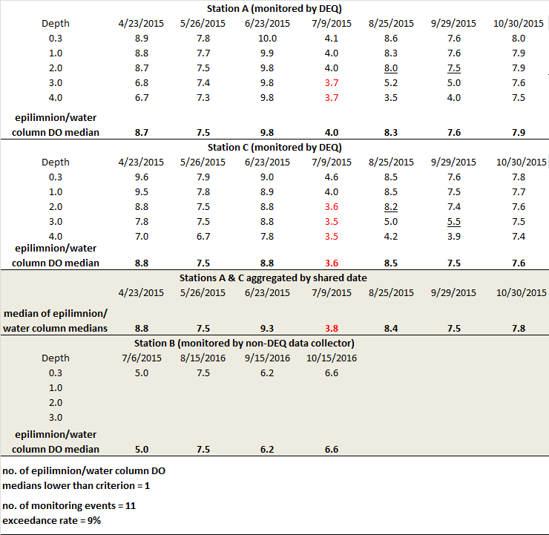

since each station would be weighted equally, regardless of how deep they are. Low DO occurring in a shallow, quiescent cove would not get “swamped out” by all the not-as-low DO samples taken in the well-mixed center of the lake/reservoir, where the water epilimnion/water column is probably deeper. This is especially true if the cove station is sampled on a date when no other samples are taken in the water body, since the sample(s) taken at that station will represent the entire water body on that date.

However, this advantage can also be seen as a disadvantage. It can be argued that deeper stations should be weighted more than shallower stations since they represent more of the three-dimensional habitat. Additionally, a station that is only monitored at the surface (such as one visited by a citizen scientist) would be represented the same in the assessment as a DEQ station that is sampled throughout the entire epilimnion (see the contrast between Station A/ C samples and Station B samples in Table 4). Surface samples may be adequately representative of the epilimnion/water column in well-mixed shallow water bodies, but they may lead to an overestimation of the epilimnion/water column DO concentration in deep water bodies. Thus, in lakes/reservoirs that are monitored by “surface only” data collectors, the alternative approach could lead to more false negatives (i.e., impaired water bodies mistakenly categorized as non-impaired water bodies, see weakness #6 in Table 1). The guidance manual could include a rule that a surface-only DO dataset can only be used in an assessment when an assessor determines they are adequately representative of the epilimnion/water column. But the adoption of such a rule may introduce inconsistency in assessments performed by different staff and result in the exclusion of some non-agency datasets[3] (see weaknesses #4 and #5 in Table 1).

### 

### Incomplete Fall Turnover

### 

DEQ Central Office staff recently determined that the majority of lakes/reservoirs were not being sub-segmented into individual assessment units, but instead are being assessed holistically. The guidance manual gives staff the discretion to assess holistically. It is reasonable from a monitoring efficiency standpoint to avoid a highly refined sub-segmentation scheme, since all the sub-segments (or assessment units) would have to be monitored over an assessment period for the entire lake/reservoir to be assessed. Furthermore, it can be difficult to determine the boundaries of sub-habitats in a large lake/reservoir when bathymetry data are not available. For large Section 187 lakes/reservoirs (such as Lake Anna), the lacustrine zone (where nutrient criteria apply) is typically carved out separately from transitional waters. “Fingers” may also be carved out. But this is typically the extent of sub-segmentation in large lakes/reservoirs[4].

DEQ Central Office staff proposed updating the Monitoring and Assessment Guidance for Lakes and Reservoirs (DEQ, 2009) with language that more strongly recommends sub-segmentation, since staff recognized that vulnerable stations (those prone to DO, pH, and temperature exceedances) may be masked by assessing medium-sized and large lakes/reservoirs holistically. Staff could delineate assessment units around individual stations as they currently do for many riverine segments or they could bracket one assessment unit around multiple stations while creating a separate assessment unit for another station. It is not expected that sub-segmentation will lead to more impaired waters listings for the majority of the Commonwealth’s lakes/reservoirs. But staff have determined that more listings are likely to occur in deep reservoirs (those greater than 15 meters in depth). In such water bodies, non-stratified but hypoxic water columns tend to be encountered as fall turnover begins (see the example in Table 5). Because a thermocline is not detected during these events, the DO criterion applies throughout the water column. When station datasets are pooled across the entire water body and over the entire six-year assessment period (the current procedure), there are generally enough “non-exceedance” DO measurements in the dataset to counterbalance the exceedances that emerge during fall turnover. But when station datasets are assessed individually, stations that are prone to fall turnover-induced hypoxia have a high likelihood of being flagged as impaired.

The obvious solution to this problem is to simply maintain the current practice of assessing deep water bodies holistically and using individual measurements (the current procedure) rather than aggregations of measurements (the alternative procedure) to establish criterion attainment status. However, this seems like a “Band-Aid” solution that does not address the larger problem of potentially masked impairments. While fall turnover-induced low DO is not a problem that can be addressed with a Total Maximum Daily Load, it could still be harmful to aquatic life if there are no oxygenated refuges available. Moreover, it is possible that fall turnover itself could mask low DO caused by anthropogenic influences. It would be ideal to have a scheme that assessment staff could follow—one that does not rely too much on “best professional judgement”(see weakness #4 in Table 1)—to determine whether exceedances at a station are due solely to incomplete fall turnover. This scheme could also

**Table 5. DO (mg/l) vertical profiles taken at Smith Mountain Lake station 4AROA175.63 for a single monitoring year. Underlined measurements are the bottommost epilimnetic measurements. Red values are exceedances of the minimum DO criterion (4.0 mg/l).**

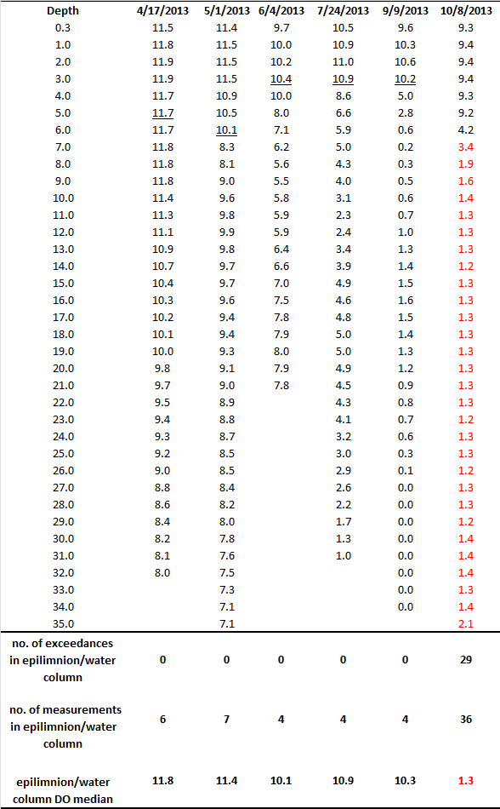

instruct staff on how to downweight fall turnover DO data while still being protective of living resources.

### Questions for the AAC

**1. Is DEQ’s current procedure for DO assessments in lakes/reservoirs sound and scientifically defensible? Does the AAC have any concerns about this procedure besides those already mentioned?**

**2. Is the alternative procedure sound and scientifically defensible? Is it a substantively better approach than the current one? Do its advantages outweigh its disadvantages?**

**3. Is there another alternative approach that DEQ should consider?**

**4. Should DEQ restrict DO assessments to vertical profile datasets in lakes/reservoirs or is it appropriate for a surface-only DO dataset to form the basis of an assessment for a lake/reservoir? If the latter, how should surface-only data (or data from shallow profiles) be used in assessments?**

**4. Can the AAC recommend a set of instructions that staff could use 1) to determine whether exceedances at a station are due solely to incomplete fall turnover , 2) to determine to what degree low DO during fall turnover might be exacerbated by pollution, and 3) to downweight fall turnover DO data while still being protective of living resources?**

### Literature Cited

Academic Advisory Committee (2005) January 2005 Report of the Academic Advisory Committee to Virginia Department of Evironmental Quality: Freshwater Nutrient Criteria.

Submitted to Division of Water Programs, Virginia DEQ on February 7, 2005. 120 pg.

Virginia Department of Environmental Quality (2009) Monitoring and Assessment Lakes and Reservoirs. Water Guidance Memo No. 09-2005. Richmond, Virginia. 31 pg.

Virginia Department of Environmental Quality (2018) 2018 Water Quality Assessment Guidance Manual. Water Guidance Memo No. GM18-2001. Richmond, Virginia. 110 pg.

U.S Environmental Protection Agency (2002) Consolidated Assessment and Listing Methodology: Toward a Compendium of Best Practices. Office of Wetlands, Oceans, and Watersheds. Washington, DC. 375 pg.

1. The “10.5% rule” is based on guidelines from the Environmental Protection Agency ([EPA, 2002](https://www.epa.gov/sites/production/files/2015-09/documents/consolidated_assessment_and_listing_methodology_calm.pdf)) within the context of conventional parameter 305(b) assessments. It is interchangeable with the “10% rule”.
2. Out of the 137 lake/reservoir assessment units monitored by DEQ over the 2013 to 2018 period, 20% were monitored at two stations and 7% were monitored at three or more stations. When citizen monitoring stations are included, 20% of monitored lake/reservoir assessment units have two stations and 14% have three or more stations. One lake/reservoir assessment unit has nine monitoring stations (five managed by DEQ and four managed by citizens).
3. Of the 41 most recently active citizen monitoring stations where “assessable” lake/reservoir DO datasets were generated, only five stations are associated with DO datasets that would be categorized as “surface only”. But four of them were the sole station in their respective assessment unit. At ten stations, citizen scientists took “bottom only” measurements during the winter and spring while sampling the upper three meters during the rest of the year. Full vertical profiles were consistently generated at most of the remaining stations.
4. The average size of a lake/reservoir assessment unit (to date) is 460 acres. The largest assessment unit is 30,665 acres and is located in Kerr Reservoir.